(HONORS) GEOMETRY NAME: _______________________
Unit 4 Lesson 1 - Apply Triangle Sum Properties BLK: _____ DATE:____________
And Angle Relationships

 | Type of ∆ | Definition | Picture
CLASSIFICATION BY  SIDES | Equilateral Triangle
CLASSIFICATION BY  SIDES | Isosceles Triangle
CLASSIFICATION BY  SIDES | Scalene Triangle
CLASSIFICATION BY  ANGLES | Equiangular Triangle
CLASSIFICATION BY  ANGLES | Acute Triangle
CLASSIFICATION BY  ANGLES | Right Triangle
CLASSIFICATION BY  ANGLES | Obtuse Triangle

Interior Angles –

Exterior Angles –

Corollary -

The sum of the angles of a triangle are If two triangles have two angles that are
_____________________. ___________, then the third angle is also ___________
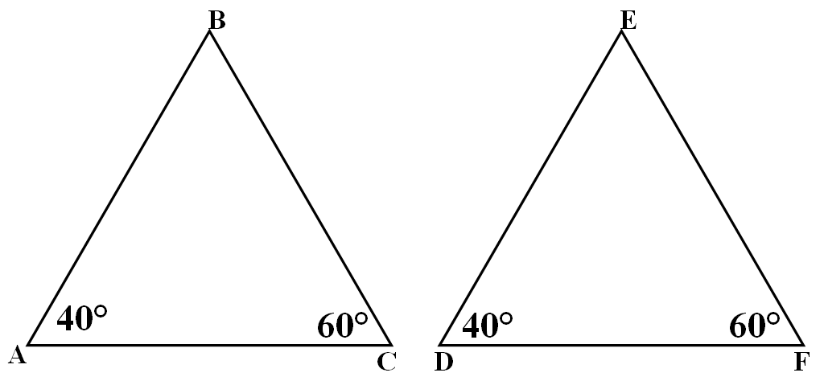

b
a

c

The measure of an exterior angle of a triangle The acute angles of a right triangle are
is equal to the sum of the measures of the two ____________________.
remote interior angles.
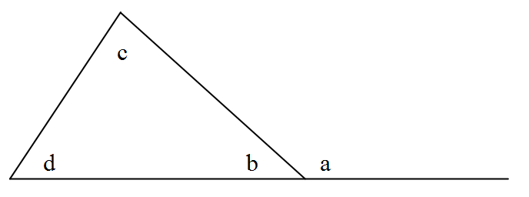
a

c

Classify the triangle by its sides and angles.
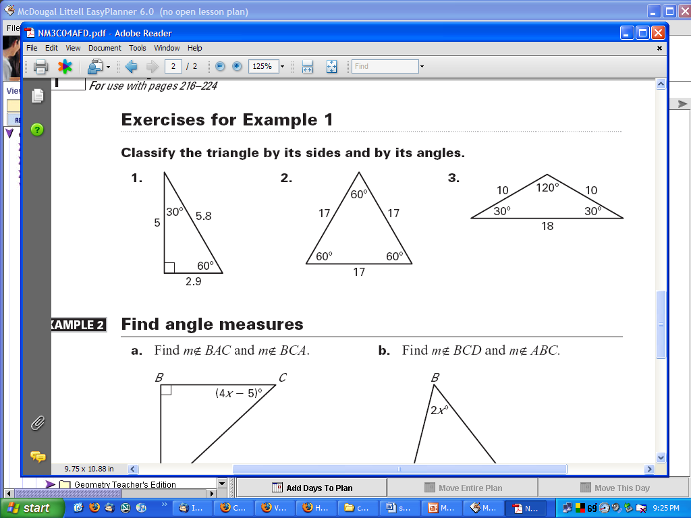

- Find the value of x. Then classify the triangle by its angles.
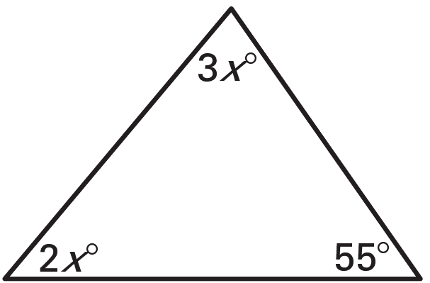
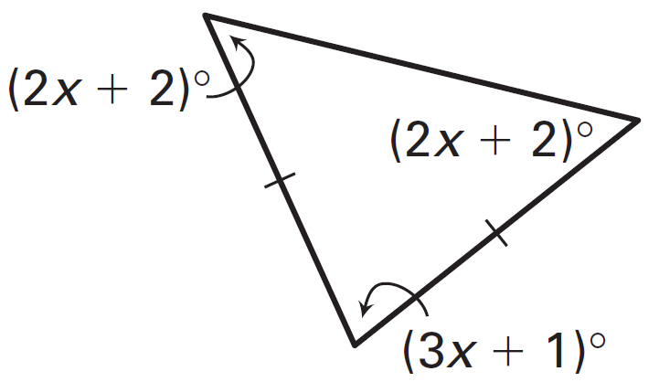
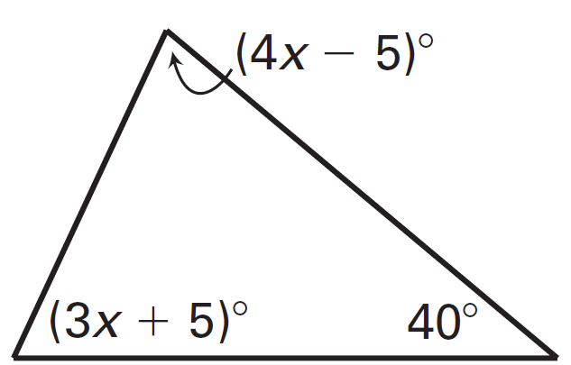

- Find the measure of each exterior angle shown.

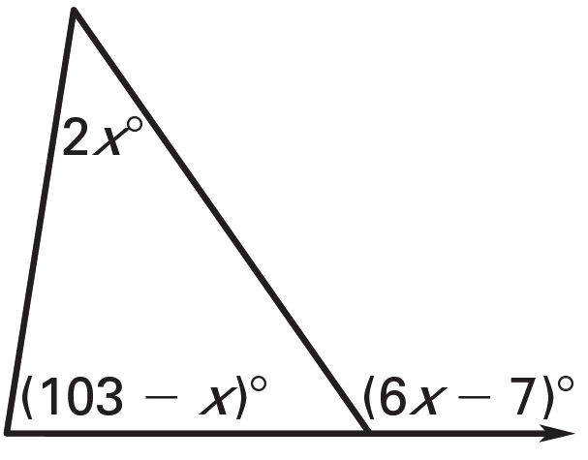
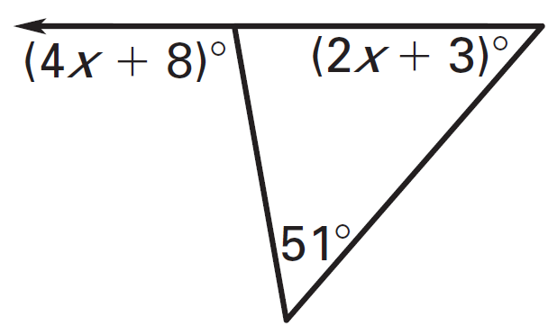
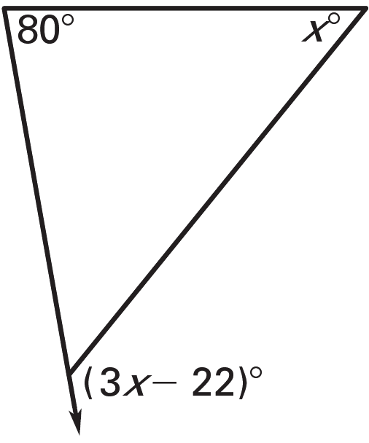

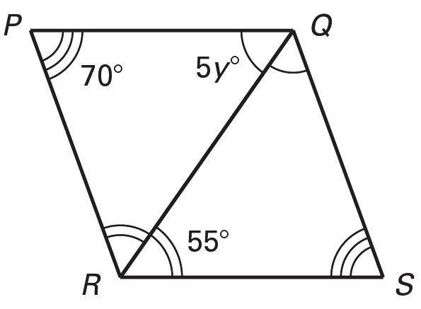
- Solve for the variables.
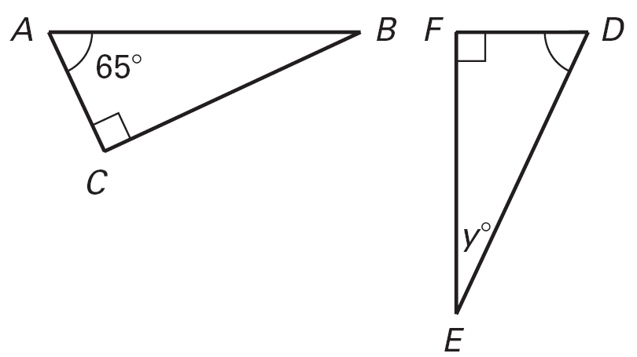

7. Find the measure of each missing angle.


